**Experiment 6:**

**Aim:** Creating a pipeline using jenkinsfile.

**Procedure:**

**Step 1:** Configure the job to get the code from github and the jenkinsfile from github then run the job. Here the pipeline code will configure the pipeline such that first is the build phase and will echo ‘build stage’ as output and will then configure the second part of the pipeline as Test and run the ‘mvn clean’ command on the project.

Pipeline code:

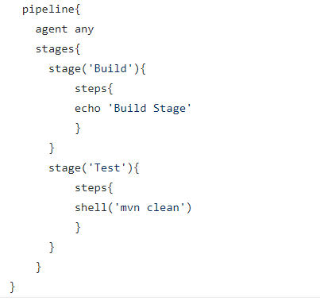

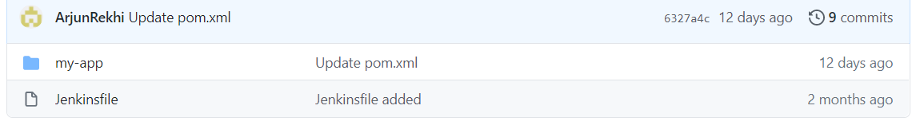

**Step 2:** Configure the Jenkins jobs to copy the Jenkinsfile from github and execute the jobs as said in the file. The name of the file should be ‘Jenkinsfile’ without any extension.

Configuration of Jenkins jobs:

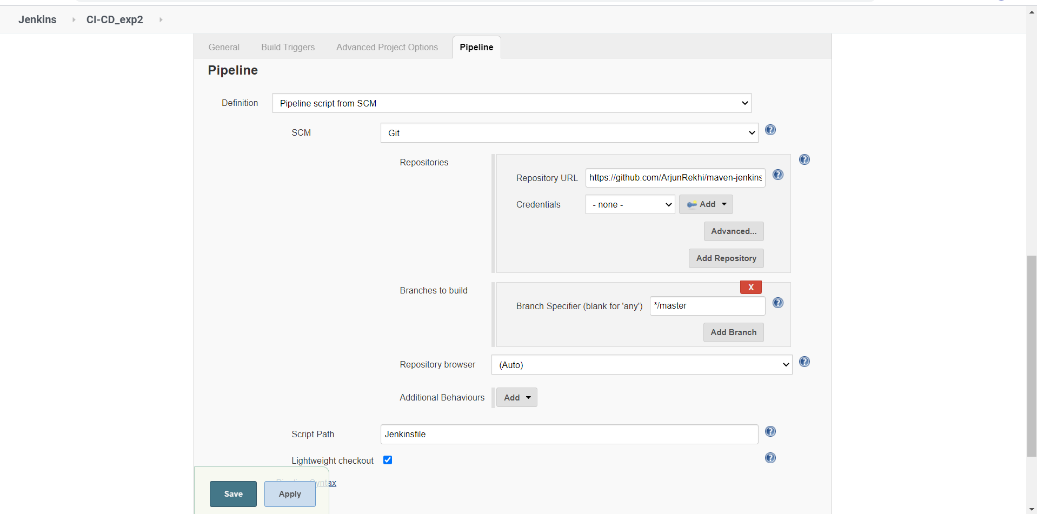

**Step 3:** Click on build now to run the job

Output:

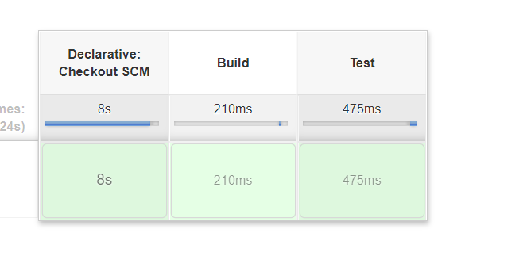

Output as seen in console output:

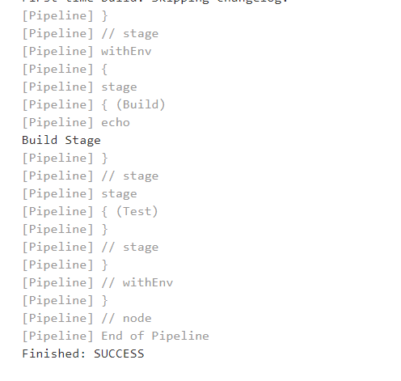

Submitted by:

Arjun Rekhi

500068109

R171218028